

Data Structures and Algorithms

23CSE113 LAB
MANUAL

Submitted by

Name | A M FAYAZ
Roll Number | AV.SC.U4CSE25010
Year/Sem/Section | 1st YEAR / SEM-3 / CSE-A
Credits | 05

Submitted to | DR .RAJ KUMAR BATCHU
Designation | ASST.PROFFESSOR (Sl. Grade)
Department | SCHOOL OF COMPUTING

Index
S. No | TITLE | PAGE NO | REMARKS
1 | a)A rocket launch system displays a count down before launch. Instead of using a loop , implement the countdown using recursion. Write a recursive program to display count from n to 1 followed by Launch.  b) An HR department stores employee IDs in a list. Develop a program to search for a given employee ID. Write a recursive function to search for a employee ID in a list.  c)  d) In a logistical company ,the number of possible ways to arrange n different parcels is calculated using the factorial formula(n!).Develop a recursive program to calculate the factorial of a given number.  e) Write a recursive python program to print the first n terms of the Fibonacci series. | 3-10
2 | a)write a python program to implement linear search on the given input.  b)write a python program to perform binary search on the given input. Verify by taking input as sorted array and unsorted array. | 10-22
3 | a) write a python program to implement bubble sort.  b) write a python program to implement selection sort.  c) write a python program to implement insertion sort.  d) write a python program to implement merge sort.  e) write a python program to implement quick sort. | 22-47
4 | Write a python programme to implement a single linked list which could perform the below operations ,by taking an input from the user.  1)create a linked list  2)Insert at beginning  3)Insert at end  4)insert at index  5)Delete by value  6)Delete First Node  7)Delete Last Node  8)Count number of nodes  9)Display/Traverse  10)Exit | 48-57
5 |  | 57-74
6 |  | 75-85
7 |  | 86-90

Week-1
1)Aim: A rocket launch system displays a count down before launch. Instead of using a loop , implement the countdown using recursion. Write a recursive program to display count from n to 1 followed by Launch.
Program:
def LaunchRocket(n):
while n>=0:
if n==0:
print("Rocket Launch--")
break
print(n)
n=n-1
n=int(input("Countdown starts from:"))
LaunchRocket(10)
Output:
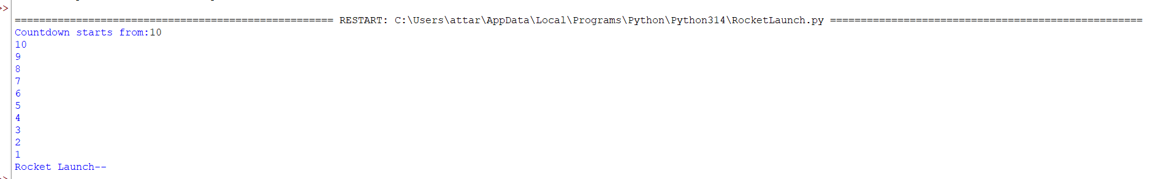

Explanation:
· The function launch(n) prints the current value of n.
· If n is greater than 0, it decreases n by 1 and calls itself recursively.
· The recursion continues until n becomes 0, which is the base case, and the function stops.

Error Table:
S.No | Error Obtained | Rectification
01. | Didn’t write the print statement after definition. | After execution I found the mistake and added it.

2)Aim: An HR department stores employee IDs in a list. Develop a program to search for a given employee ID. Write a recursive function to search for a employee ID in a list.
Program:
def Search(list,Search_element):
n=len(list)
i=0
while i<=n:
if(list[i]==Search_element):
return i
else:
i+=1
return -1
E_ID=[15,10,25,20,40]
key=int(input("Enter the Employee ID you want to search:"))
index =Search(E_ID,key)
print(index)
if index!=-1:
print(f"The Employee_ID is at index{index}")
else:
print("The given Employee_ID is invalid")
Output:
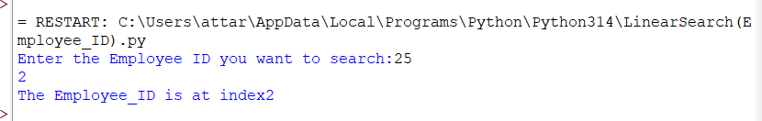
Explanation:
This program uses an iterative linear search to find an Employee ID in a list.
- The function Search(list, Search_element) is defined with two parameters:
  - list: The list in which the search is performed.
  - Search_element: The Employee ID to be searched.
- Inside the function, n = len(list) stores the total number of elements in the list, and i = 0 initializes the index for traversal.
- The while loop checks each element of the list one by one. If the current element matches the search element (list[i] == Search_element), the function returns the index i.
- If the current element does not match, the index is incremented using i += 1, and the search continues until all elements have been checked.
- If the Employee ID is not found after traversing the list, the function returns -1.
- The list E_ID = [15, 10, 25, 20, 40] is created, and the user is prompted to enter the Employee ID to search.
- The returned index is stored in the variable index.
- If index is not equal to -1, the program displays the index where the Employee ID is found. Otherwise, it prints "The given Employee_ID is invalid."
Error Table:

S.NO | Error Obtained | Rectification
1 | Index Error: list index out of range | Change the loop condition from while i <= n: to while i < n: so that the index does not exceed the valid range of the list.

3)Aim:
Program:
def CompoundInterest(P,N):
if N==0:
return 1
else:
return P**N
PrincipalRate=int(input("Enter the amount: "))
Year=int(input("Enter the number of years:"))
result=CompoundInterest(PrincipalRate,Year)
print(f"Compound Interest is:{result} Rupees only")
Output:
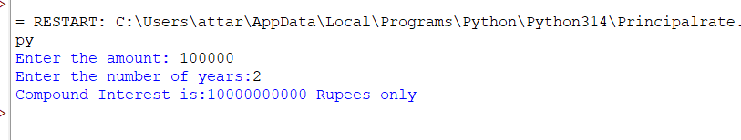
Explanation:
. The program is used to calculate the value of an amount raised to the power of the number of years using a function.
. It takes two inputs from the user:
- P → Principal amount (entered as PrincipalRate)
- N → Number of years (entered as Year)
. The function CompoundInterest(P, N) is called to calculate the result.
. If the value of N is 0, the function returns 1, since any number raised to the power 0 is 1.
. If N is not 0, the function returns P ** N, which calculates the principal amount raised to the given number of years using the exponent (**) operator.
. The returned value is stored in the variable result.
. Finally, the program prints the calculated result in the format:
"Compound Interest is: result Rupees only."

Error Table:
S. No | Error Obtained | Rectification
01. | Not a int value of n we can also take float in place of int, I have taken float value to check. | By replacing int by float.

4)Aim: In a logistical company ,the number of possible ways to arrange n different parcels is calculated using the factorial formula(n!).Develop a recursive program to calculate the factorial of a given number.
Program:
def fact(n):
if n==0:
return 1
elif n==1:
return 1
else:
return n*fact(n-1)
n=int(input("Enter the number of parcels:"))
print(fact(n))

Output:
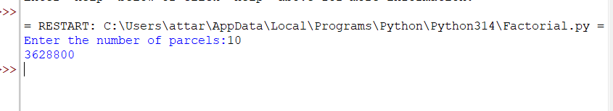
Explanation:
· The program defines a recursive function fact(n) to calculate the factorial of a number.
· The base condition checks if n ==0 or 1. If true, it returns 1 (for factorial, 0! = 1 and 1! = 1).
· Otherwise, the function returns n * fact(n-1), multiplying the current number by the factorial of the previous number.
· The function is called with the value 10.
· Finally, the program prints the factorial of 10, which is 3628800.
Error Table:
S. No | Error Obtained | Rectification
01. | No Errors obtained | ---------------------------------------------------

5)Aim: Write a recursive python program to print the first n terms of the Fibonacci series.
Program:
def fib(n):
if n==0:
return 0
elif n==1:
return 1
else:
return fib(n-1)+fib(n-2)
n=int(input("Enter the number of terms:"))
while n>=0:
fib(n)
print(fib(n))
n=n-1
Output:
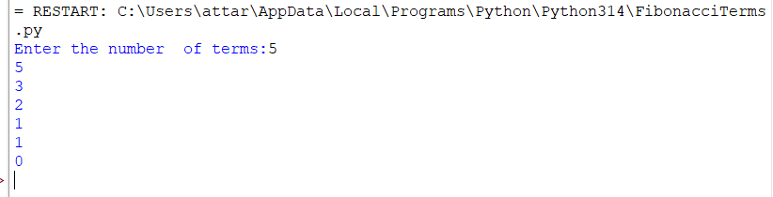

Explanation:
- The program uses a recursive function fib(n) to calculate Fibonacci numbers.
- The function returns 0 when n == 0 and 1 when n == 1. These are the base conditions of the recursion.
- For values greater than 1, the function returns the sum of the previous two Fibonacci numbers using fib(n-1) + fib(n-2).
- The user enters the number of terms (n).
- A while loop repeatedly calls the fib() function, prints the Fibonacci number corresponding to the current value of n, and then decreases n by 1.
- The loop continues until n becomes less than 0.
- Finally, the program displays the Fibonacci numbers in reverse order (from the entered value down to 0).
Error Table:

S. No | Error Obtained | Rectification
01. | No Errors obtained | Fibonacci numbers are printed in reverse order instead of the correct sequence.  Replace the while loop with a for loop such as for i in range(n): print(fib(i)) to display the Fibonacci series from 0 to n-1 in the correct order.

WEEK-2
Aim:
Write a python program to implement linear search on the given input.
Program:
def Linear_Search(nums,n,k):
n=len(nums)
i=0
while i<n:
if(nums[i]==k):
return i
else:
i+=1
return -1
n=int(input("Enter the number of elements in the array:"))
arr=[]
for i in range(n):
arr.append(int(input("Enter the element:")))
key=int(input("Enter the element to sarch in the array:"))
result=Linear_Search(arr,n,key)
if result!=-1:
print("Element found at index:"+str(result))
else:
print("Element does not exist in the array")

Output:
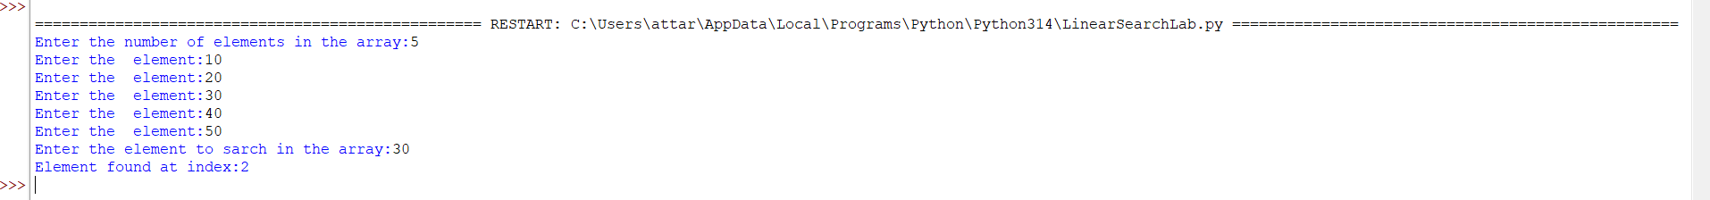

Explanation:
In this program, the function Linear_Search(nums, n, k) takes an array and a key as input. The variable i starts from 0, which represents the first index of the array. The while loop compares nums[i] with the key k.
- If nums[i] == k, the function returns the index i, meaning that the element has been successfully found.
- If the element does not match, i is increased by 1 and the next element is checked.
- If all elements are checked and the key is not found, the function returns -1.
The program then displays whether the element was found or does not exist in the array
.
  S. No. | Errors Obtained | Rectified
  1 | The value of n was passed to the function, but it was not actually required because the array length can be obtained directly. | Used n = len(nums) inside the function to get the actual number of elements.
  2 | If the search key was not found, there was no proper return value to indicate failure. | Added return -1 after the loop to indicate that the element does not exist.
  3 | The index variable i must be increased after an unsuccessful comparison. | Added i += 1 inside the else block.
  4 | The input message contained a spelling mistake: "sarch". | Corrected it to "search".
  5 | The output statement used string concatenation with an integer index. | Used str(result) to convert the index into a string before concatenation.
Error Table:

Aim: Write a python program to perform binary search on the given input. Verify by taking input as sorted array and unsorted array.
Program:
def Binary_Search(arr,key):
low=0
high=len(arr)-1
while low<=high:
mid=(low+high)//2
if(arr[mid]==key):
return mid
elif(arr[mid]<key):
low=mid+1
else:
high=mid-1
return -1
n=int(input("Enter the number of elements:"))
arr=[]
for i in range(n):
arr.append(int(input("Enter the element:")))
if arr == sorted(arr):
print("Array is already sorted")
else:
print("The array is not sorted")
print("The array is sorting")
arr.sort()
print("Sorted list:"+str(arr))
key=int(input("Enter the element to Search:"))
result=Binary_Search(arr,key)
if result!=-1:
print(f"Element {key} found at index {result}")
else:
print(f"Element {key} is not present in the list")

Output:
A)If the array is sorted:
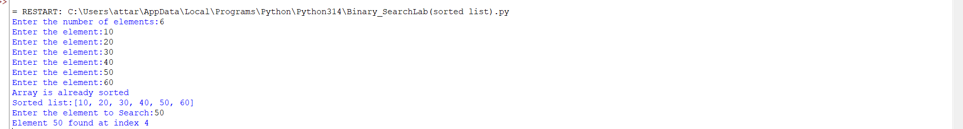

B)If the array is not sorted:
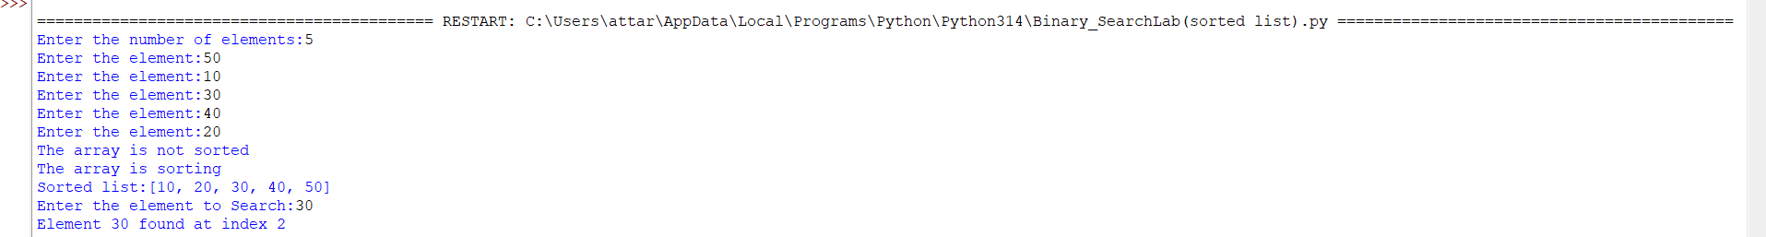
Explanation:
In this program, the user first enters the number of elements and the elements of the array. The program then checks whether the array is already sorted using:
if arr == sorted(arr):
If the array is already sorted, the program displays "Array is already sorted". Otherwise, it sorts the array using arr.sort().
The Binary_Search() function then performs the search. It uses three variables:
- low – represents the first index of the current search range.
- high – represents the last index of the current search range.
- mid – represents the middle index of the search range.
The middle element is calculated using:
mid = (low + high) // 2
The program compares the middle element with the search key:
- If arr[mid] == key, the element is found and its index is returned.
- If arr[mid] < key, the key must be in the right half, so low is changed to mid + 1.
- If arr[mid] > key, the key must be in the left half, so high is changed to mid - 1.

Error Table:

S.NO | Errors Obtained | Rectified
1 | Binary Search cannot be performed correctly on an unsorted array. | Checked whether the array is sorted and used arr.sort() when necessary.
2 | The middle index may be calculated incorrectly if normal division is used. | Used mid = (low + high) // 2 to obtain an integer index.
3 | The search range was not reduced correctly when the middle element was smaller than the key. | Updated low = mid + 1 to search the right half
4 | The search range was not reduced correctly when the middle element was greater than the key. | Updated high h = mid - 1 to search the left half.
5 | There was no proper indication when the search element was not found. | Added return -1 and displayed "Element is not present in the list" when the result is -1.

Week-3
Code:
def BubbleSort(arr):
n=len(arr)
for i in range(n-1):
for j in range(n-i-1):
if(arr[j]>arr[j+1]):
arr[j],arr[j+1]=arr[j+1],arr[j]
return arr
arr=[5,7,2,9,4]
result=BubbleSort(arr)
print(result)
Output:
Explanation:
The above Python program uses the Bubble Sort algorithm to arrange the elements of an array in ascending order.
1. Function Definition
def BubbleSort(arr):
This defines a function named BubbleSort that accepts an array (list) called arr.
2. Finding the Length
n = len(arr)
The len() function finds the number of elements in the list and stores it in the variable n.
3. Outer Loop
for i in range(n-1):
The outer loop controls the number of passes through the list. Bubble Sort requires a maximum of n-1 passes to sort n elements.
4. Inner Loop
for j in range(n-i-1):
The inner loop compares adjacent elements. After every pass, the largest unsorted element moves to its correct position at the end of the list.
5. Comparing Elements
if arr[j] > arr[j+1]:
The current element is compared with the next element. If the current element is greater than the next element, they need to be exchanged.
6. Swapping Elements
arr[j], arr[j+1] = arr[j+1], arr[j]
This statement swaps the two elements. Python allows two values to be exchanged in a single statement without requiring a temporary variable.
7. Returning the Sorted List
return arr
After sorting is completed, the function returns the sorted list.
8. Input
The given list is:
arr = [5, 7, 2, 9, 4]
9. Function Call
result = BubbleSort(arr)
The BubbleSort() function is called with the given list, and the sorted result is stored in result.
10. Displaying the Result
print(result)
This displays the sorted list on the screen.
Output
[2, 4, 5, 7, 9]
Error Table:
S .No. | Error Occurred | Rectification
1 | No error occurred | No rectification was required. The program executed successfully and produced the output [2,4,5,7,9]

Code:
def Insertion_Sort(arr):
n=len(arr)
for i in range(1,n):
key=arr[i]
j=i-1
while j>=0 and arr[j]>key:
arr[j+1]=arr[j]
j=j-1
arr[j+1]=key
return arr

arr=[50,20,40,30,10]
result=Insertion_Sort(arr)
print(result)
Output:
Explanation:
The given Python program uses the Insertion Sort algorithm to arrange the elements of a list in ascending order.
- def Insertion_Sort(arr):
Defines a function named Insertion_Sort() that takes a list as input.
- n = len(arr)
Finds the number of elements in the list.
- for i in range(1, n):
Starts from the second element because the first element is considered already sorted.
- key = arr[i]
Stores the current element that needs to be inserted into its correct position.
- j = i - 1
Sets j to the position immediately before the current element.
- while j >= 0 and arr[j] > key:
Compares the elements before key. If an element is greater than key, it is shifted one position to the right.
- arr[j + 1] = arr[j]
Moves the larger element one position forward.
- j = j - 1
Moves to the previous element for comparison.
- arr[j + 1] = key
Inserts key into its correct position.
- return arr
Returns the sorted list
Error Table:
S .No. | Error Occurred | Rectification
1 | Identation erroroccurred because the statement arr[j+1] = key was incorrectly indented outside the for loop. | Corrected the indentation of  arr[j+1] = key so that it is properly aligned within the for loop.

Code:
def SelectionSort(arr):
n=len(arr)
for i in range(n-1):
min_index=i
for j in range(i+1,n):
if arr[j]<arr[min_index]:
min_index=j
arr[i],arr[min_index]=arr[min_index],arr[i]
return arr
arr=[64,25,12,22,11]
result=SelectionSort(arr)
print(result)
Output:

Explanation:
The given Python program uses the Selection Sort algorithm to arrange the elements in ascending order.
- def SelectionSort(arr):
Defines a function named SelectionSort() that accepts a list.
- n = len(arr)
Finds the number of elements in the list.
- for i in range(n-1):
Repeats the sorting process for each position except the last one.
- min_index = i
Assumes that the current position contains the smallest element.
- for j in range(i+1, n):
Searches the remaining unsorted portion of the list.
- if arr[j] < arr[min_index]:
Compares the current element with the smallest element found so far.
- min_index = j
Updates the position of the smallest element when a smaller value is found.
- arr[i], arr[min_index] = arr[min_index], arr[i]
Swaps the smallest element with the element at position i.
- return arr
Returns the sorted list.
Error Table:
S .No. | Error Occurred | Rectification
1 | NameError occurred because SelectionSort was incorrectly written as Selection_Sort while calling the function. | Changed the function call to SelectionSort(arr) so that it matches the function definition.

Code:
def merge_sort(arr):
if len(arr)<=1:
return arr
mid=len(arr)//2
left=arr[:mid]
right=arr[mid:]
merge_sort(left)
merge_sort(right)
i=j=k=0
while i<len(left) and j<len(right):
if(left[i]<=right[j]):
arr[k]=left[i]
i+=1
else:
arr[k]=right[j]
j+=1
k+=1
while i<len(left):
arr[k]=left[i]
i+=1
k+=1
while j<len(right):
arr[k]=right[j]
j+=1
k+=1
return arr
arr=[10,30,50,70,90,60]
print(merge_sort(arr))
Output:

Explanation:
def merge_sort(arr):
Defines a function named merge_sort() that accepts a list.
if len(arr) <= 1:
Checks whether the list has zero or one element. Such a list is already sorted.
mid = len(arr) // 2
Finds the middle position of the list.
left = arr[:mid] and right = arr[mid:]
Divides the list into two halves: left and right.
merge_sort(left) and merge_sort(right)
Recursively sorts both halves.
i = j = k = 0
Initializes indexes for the left list, right list, and original list.
while i < len(left) and j < len(right):
Compares elements from both halves and places the smaller element into the original list.
while i < len(left):
Copies any remaining elements from the left half.
while j < len(right):
Copies any remaining elements from the right half.
return arr
Returns the sorted list.
Error Table:
S.NO. | Error Occurred | Rectification
1 | TypeError: object of type 'NoneType' has no len() may occur because the recursive calls merge_sort(left) and merge_sort(right) depend on their | Change them to left = merge_sort(left) and right = merge_sort(right).

Code:
def quickSort(a, low, high):
if low < high:
i = low
j = high
pivot = low
while i < j:
while i <len(a) and a[i] <= a[pivot]:
i += 1
while a[j] > a[pivot]:
j -= 1
if i < j:
a[i], a[j] = a[j], a[i]
# Place pivot in correct position
a[j], a[pivot] = a[pivot], a[j]

# Recursive calls
quickSort(a, low, j - 1)
quickSort(a, j + 1, high)

# Input
a = list(map(int, input("Enter numbers to sort: ").split()))
n = len(a)

quickSort(a, 0, n - 1)
print("Sorted array:", a)
Output:
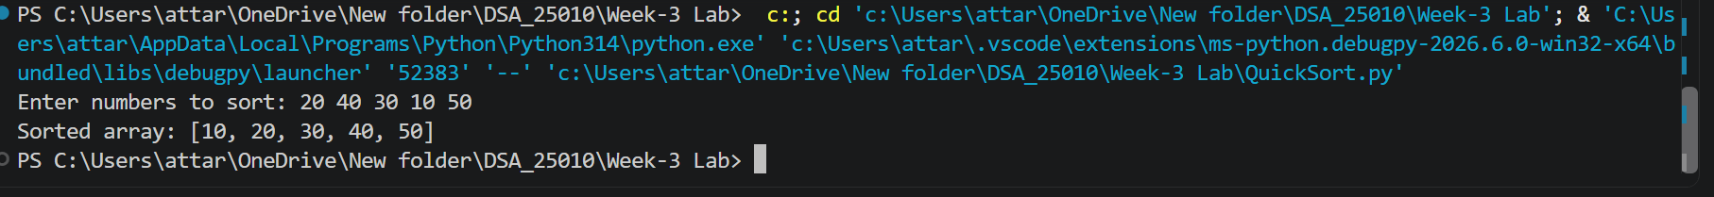
Explanation:
The program implements the Quick Sort algorithm.
It takes a list of numbers as input from the user.
The first element is selected as the pivot.
Two variables, i and j, are used to scan the array.
Elements are compared with the pivot and swapped when necessary.
The pivot is placed in its correct position after partitioning.
The program uses recursion to sort the left and right portions.
The process continues until the entire array is sorted.
Finally, the sorted array is displayed.
Example output: [10, 20, 30, 40, 50]
Error Table:
S.No | Error Occurred | Rectification
1 | IndexError: list index out of range may occur if the condition in the first inner loop is changed incorrectly and allows i to go beyond the valid array range. | Added the condition i < len(a) to ensure that i remains within the valid range of the array.

Week-4
Aim: Write a python programme to implement a single linked list which could perform the below operations ,by taking an input from the user.
1)create a linked list
2)Insert at beginning
3)Insert at end
4)insert at index
5)Delete by value
6)Delete First Node
7)Delete Last Node
8)Count number of nodes
9)Display/Traverse
10)Exit
Code:
class Node:
def __init__(self, data):
self.data = data
self.next = None

class SLL:
def __init__(self):
self.head = None

# 1. Create Linked List
def create(self):
n = int(input("Enter number of nodes: "))

# Clear existing list before creating a new one
self.head = None

for i in range(n):
data = int(input("Enter data: "))
new_node = Node(data)

if self.head is None:
self.head = new_node
else:
temp = self.head

while temp.next is not None:
temp = temp.next

temp.next = new_node

print("Linked List created successfully.")

# 2. Insert at Beginning
def insert_beginning(self):
data = int(input("Enter data: "))

new_node = Node(data)
new_node.next = self.head
self.head = new_node

print(f"Inserted {data} at the beginning.")

# 3. Insert at End
def insert_end(self):
data = int(input("Enter data: "))

new_node = Node(data)

if self.head is None:
self.head = new_node
print(f"Inserted {data} at the end.")
return

temp = self.head

while temp.next is not None:
temp = temp.next

temp.next = new_node

print(f"Inserted {data} at the end.")

# 4. Insert at Index
def insert_at_index(self):
data = int(input("Enter data: "))
index = int(input("Enter index: "))

if index < 0:
print("Invalid index.")
return

if index == 0:
new_node = Node(data)
new_node.next = self.head
self.head = new_node

print(f"Inserted {data} at index {index}.")
return

temp = self.head

# Move to the node before the required index
for i in range(index - 1):
if temp is None:
print("Index out of range.")
return

temp = temp.next

if temp is None:
print("Index out of range.")
return

new_node = Node(data)

new_node.next = temp.next
temp.next = new_node

print(f"Inserted {data} at index {index}.")

# 5. Delete from Beginning
def delete_beginning(self):
if self.head is None:
print("List is empty.")
return

deleted_data = self.head.data
self.head = self.head.next

print(f"Deleted {deleted_data} from the beginning.")

# 6. Delete from End
def delete_end(self):
if self.head is None:
print("List is empty.")
return

# Only one node
if self.head.next is None:
deleted_data = self.head.data
self.head = None

print(f"Deleted {deleted_data} from the end.")
return

temp = self.head

# Move to second-last node
while temp.next.next is not None:
temp = temp.next

deleted_data = temp.next.data
temp.next = None

print(f"Deleted {deleted_data} from the end.")

# 7. Delete from Index
def delete_at_index(self):
index = int(input("Enter index: "))

if self.head is None:
print("List is empty.")
return

if index < 0:
print("Invalid index.")
return

# Delete first node
if index == 0:
deleted_data = self.head.data
self.head = self.head.next

print(f"Deleted {deleted_data} from index {index}.")
return

temp = self.head

# Move to node before the required index
for i in range(index - 1):
if temp.next is None:
print("Index out of range.")
return

temp = temp.next

if temp.next is None:
print("Index out of range.")
return

deleted_data = temp.next.data
temp.next = temp.next.next

print(f"Deleted {deleted_data} from index {index}.")

# 8. Count Nodes
def count_nodes(self):
count = 0
temp = self.head

while temp is not None:
count += 1
temp = temp.next

print("Number of nodes:", count)

# 9. Display
def display(self):
if self.head is None:
print("List is empty.")
return

temp = self.head

while temp is not None:
print(temp.data, end=" -> ")
temp = temp.next

print("None")

# Main Program
sll = SLL()

while True:
print("\n----- SINGLY LINKED LIST -----")
print("1. Create Linked List")
print("2. Insert at Beginning")
print("3. Insert at End")
print("4. Insert at Index")
print("5. Delete from Beginning")
print("6. Delete from End")
print("7. Delete from Index")
print("8. Count Number of Nodes")
print("9. Display")
print("10. Exit")

choice = int(input("Enter your choice: "))

if choice == 1:
sll.create()

elif choice == 2:
sll.insert_beginning()

elif choice == 3:
sll.insert_end()

elif choice == 4:
sll.insert_at_index()

elif choice == 5:
sll.delete_beginning()

sll.delete_end()

elif choice == 7:
sll.delete_at_index()

elif choice == 8:
sll.count_nodes()

elif choice == 9:
sll.display()

elif choice == 10:
print("Exiting from the program...")
break

else:
print("Invalid choice.")
Output:
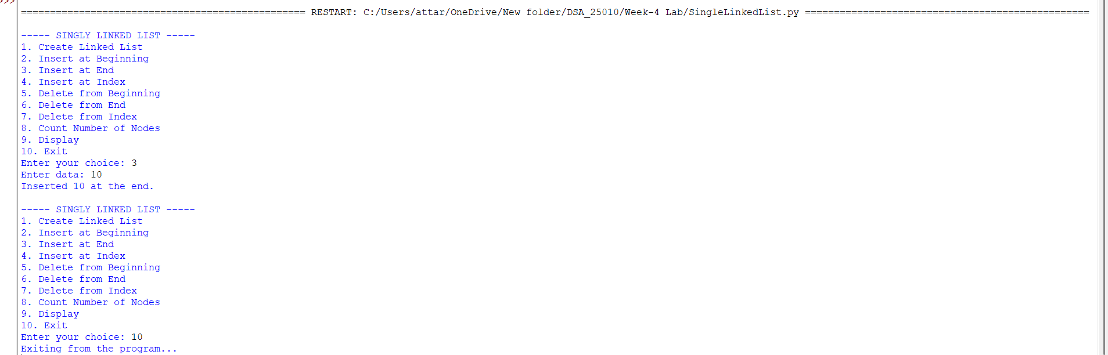
Explanation:
Singly Linked List in Python
1. Introduction
A Singly Linked List is a linear data structure in which each element is called a node. Each node contains two parts:
- Data – stores the value.
- Next – stores the address/reference of the next node.
The last node points to None, which indicates the end of the linked list.
This Python program implements a singly linked list and provides various operations such as creating, inserting, deleting, counting, and displaying nodes.

2. Node Class
The Node class is used to create individual nodes of the linked list.
class Node:
def __init__(self, data):
self.data = data
self.next = None
Explanation
- __init__() is the constructor of the class.
- data stores the value of the node.
- next stores the reference to the next node.
- Initially, next is set to None because the new node is not connected to another node.
For example:
+-------+-------+
| Data | Next |
+-------+-------+
| 10 | None |
+-------+-------+

3. SLL Class
The SLL class represents the singly linked list.
class SLL:
def __init__(self):
self.head = None
Explanation
- head stores the reference of the first node in the linked list.
- Initially, the list is empty, so head is set to None.
Example:
head
|
v
None

4. Create Linked List
The create() function is used to create a new linked list.
def create(self):
n = int(input("Enter number of nodes: "))
self.head = None
The user first enters the number of nodes. The program then takes data for each node and connects the nodes one after another.
If the list is empty, the first node becomes the head.
if self.head is None:
self.head = new_node
For the remaining nodes, the program moves to the last node and attaches the new node.
10 -> 20 -> 30 -> None

5. Insert at Beginning
The insert_beginning() function adds a new node at the start of the list.
new_node = Node(data)
new_node.next = self.head
self.head = new_node
Working
Suppose the list is:
20 -> 30 -> None
If 10 is inserted at the beginning:
10 -> 20 -> 30 -> None
The new node becomes the new head.

6. Insert at End
The insert_end() function adds a new node at the end of the list.
First, the program checks whether the list is empty.
if self.head is None:
self.head = new_node
If the list is not empty, the program moves through the list until it reaches the last node.
while temp.next is not None:
temp = temp.next
Then the new node is connected to the last node.
Example:
Before insertion:
10 -> 20 -> 30 -> None
After inserting 40:
10 -> 20 -> 30 -> 40 -> None

7. Insert at Index
The insert_at_index() function inserts a new node at a specified position.
The user provides:
- Data to insert
- Index where the node should be inserted
Python uses zero-based indexing, which means:
10 -> 20 -> 30 -> None
0 1 2
If 15 is inserted at index 1:
10 -> 15 -> 20 -> 30 -> None
The program first checks whether the index is valid. If the index is 0, the new node is inserted at the beginning.
For other indexes, the program moves to the node just before the required position and changes the links.

8. Delete from Beginning
The delete_beginning() function removes the first node.
deleted_data = self.head.data
self.head = self.head.next
The head is moved to the second node.
Example:
Before deletion:
10 -> 20 -> 30 -> None
After deletion:
20 -> 30 -> None
If the list is empty, the program displays:
List is empty.

9. Delete from End
The delete_end() function removes the last node.
The program first checks whether the list is empty or contains only one node.
For a list containing multiple nodes, it moves to the second-last node.
while temp.next.next is not None:
temp = temp.next
Then it removes the connection to the last node.
Example:
Before deletion:
10 -> 20 -> 30 -> None
After deletion:
10 -> 20 -> None

10. Delete from Index
The delete_at_index() function removes a node from a specified index.
For example:
10 -> 20 -> 30 -> 40 -> None
0 1 2 3
If the user enters index 2, the node containing 30 is deleted.
Result:
10 -> 20 -> 40 -> None
The program changes the next reference of the previous node so that it points to the node after the deleted node.

11. Count Nodes
The count_nodes() function counts the total number of nodes.
count = 0
temp = self.head

while temp is not None:
count += 1
temp = temp.next
The program starts from the first node and moves through every node. The counter increases by 1 for each node.
For example:
10 -> 20 -> 30 -> None
The output will be:
Number of nodes: 3

12. Display Linked List
The display() function prints all the elements of the linked list.
while temp is not None:
print(temp.data, end=" -> ")
temp = temp.next

print("None")
For example, if the list contains:
10 -> 20 -> 30
The output will be:
10 -> 20 -> 30 -> None
None represents the end of the linked list.

13. Main Program
The main program creates an object of the SLL class.
sll = SLL()
A menu is displayed to the user.
1. Create Linked List
2. Insert at Beginning
3. Insert at End
4. Insert at Index
5. Delete from Beginning
6. Delete from End
7. Delete from Index
8. Count Number of Nodes
9. Display
10. Exit
The user enters a choice, and the corresponding function is called.
For example:
if choice == 1:
sll.create()
If the user selects 1, the create() function is executed.
If the user selects 10, the program exits.
elif choice == 10:
print("Exiting from the program...")
break
The while True loop keeps displaying the menu until the user selects the Exit option.

14. Overall Working of the Program
The program follows these basic steps:
- Create an empty linked list.
- Display the menu.
- Ask the user to select an operation.
- Perform the selected operation.
- Display the result.
- Show the menu again.
- Continue until the user selects Exit.

15. Operations Supported
Operation | Purpose
Create | Creates a new linked list
Insert at Beginning | Adds a node at the start
Insert at End | Adds a node at the end
Insert at Index | Adds a node at a specific position
Delete from Beginning | Removes the first node
Delete from End | Removes the last node
Delete from Index | Removes a node from a specific position
Count Nodes | Counts the total number of nodes
Display | Shows all nodes
Exit | Terminates the program
16. Conclusion
This program demonstrates the implementation of a Singly Linked List using Python classes. It allows the user to perform important linked-list operations such as insertion, deletion, counting, and displaying elements.
The program also handles common situations such as an empty list, invalid indexes, and deletion of the only node in the list. It provides a simple menu-driven interface, making it easy for the user to perform different linked-list operations.
Error Table:

S .No. | Error Occurred | Rectification
1 | Constructor was written as _init_ instead of __init__. | Changed _init_ to __init__ in both Node and SLL classes.
2 | Node object was not initialized correctly. | Added self.data = data and self.next = None in the Node constructor.
3 | SLL object did not have a head attribute. | Added self.head = None in the SLL constructor.
4 | Insertion at an invalid index could cause an error. | Added index validation and an "Index out of range" message.
5 | Negative index was accepted. | Added a condition to display "Invalid index" for negative indexes.
6 | Deletion from an empty list could not be performed. | Added an empty-list check before deletion.
7 | Deletion from the end required special handling for a single-node list. | Added a condition to check whether the list contains only one node.
8 | The deleted node value was not displayed clearly. | Stored the deleted value in deleted_data and displayed it in the output.
9 | Creating a new linked list could retain previous nodes. | Added self.head = None at the beginning of the create() function.

